Chapter 18, Problem 46.

Determine the Fourier transform of i_{o}(t) in the circuit of Fig. 18.48.

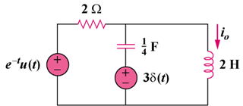

Figure 18.48
For Prob. 18.46.

